The Role of Forecasting and Planning in Business Organization

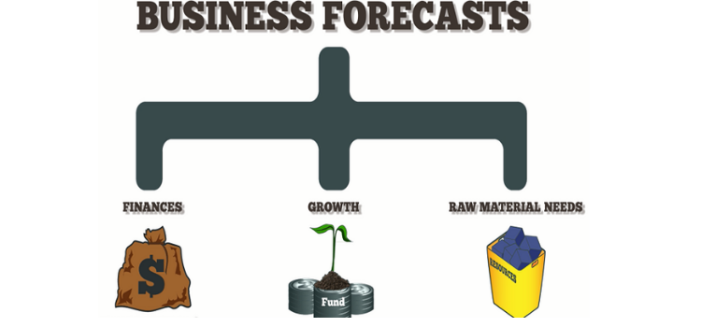

Planning and Forecasting in Business
Planning and forecasting are two sides of the same coin that any successful firm must embrace. In order to attain organizational goals and objectives, they are required.
Planning is reviewing an organization's present activities, identifying shortcomings from the previous year, and devising strategies to avoid them in future years.
It entails laying out an organization's annual goals, as well as the methods for achieving them and the resources required to do so. It is the initial stage in deciding what to do and how to execute it for management.
An organization's plan gets it to where it wishes to be in the near future. The past is important in planning.

Effects of Planning and Forecasting
It is future-oriented: Allowing managers to see and discount the future in comparison to the present. As a result, the planning quality improves. Forecasting aids in knowing these conditions. Planning is done for the future under certain known conditions. It gives planning premises knowledge, allowing managers to assess their strengths and weaknesses and take measures to meet future market demands. For example, if TV producers believe LCD or Plasma televisions will eventually replace traditional televisions, they should either modify their product mix or begin manufacturing LCD/Plasma screens. As a result, forecasting aids in the efficient allocation of resources to the most profitable company segments. Businesses may struggle to thrive in today's rapidly changing technology environment if they don't adapt.
Reduces risk: While forecasting cannot completely remove risk, it can significantly reduce it by predicting the direction in which environmental elements are changing. It aids the organization's survival in an unpredictable environment by providing hints as to what may occur in the future.
Coordination: Forecasting entails participation from all levels of the organization, including all departments. It aids in the coordination of the organization's departmental plans at all levels. People from all departments and levels are actively involved in managing corporate operations as a result of forecasting probable future changes. As a result, forecasting assists in the coordination of all plans.
Effective management: Managers can establish solid objectives and strategies for their organizations by identifying essential areas of functioning. This improves organizational efficiency, effectiveness in accomplishing objectives, management, and goal achievement.
Executive development: Forecasting improves executives' mental, conceptual, and analytical talents, allowing them to work in a planned, systematic, and scientific manner. This assists in the development of management executives.

Relationship between Forecasting and Planning
Why are planning and forecasting important in an organization? Both philanthropic and non-profit organizations have failed due to insufficient planning and forecasting. Forecasting and planning Planning, which begins with manpower selection, creates a link or bridge between the past, present, and future in order to maximize returns by bringing the future to the managers' doorstep. As the most important of all business tasks, planning has attempted to house all functions because if it fails as a house, everything else will fail, and business organizations are destined to flourish with the help of thoughtful planning.
Some people nowadays enter the business world without considering the rate of planning and forecasting because they believe that "with money, anything is possible" and that they are man enough to manage anything, which is both incorrect and abusive to the business concept. They are coming to the realization that success is based on actual planning and forecasting, not on assumptions.

Importance of Forecasting and Planning
In today's complicated and fast-changing corporate environment, the necessity for value-adding budgeting, forecasting, and financial planning is becoming increasingly apparent.
The speed and accuracy of the data provided by these procedures have significant consequences for strategic decision-making. The strategic plan should be the driving force behind the value-adding forecasting and the financial planning process. It is difficult to make budgetary decisions when organizations do not have a clear business plan.
Knowing that planning is an organic function of management is beneficial in various ways. If properly used, these topics will assist all commercial organizations, both those that have come and those that are about to arrive, particularly in the areas of pricing, quantity, manpower, money, capital control, and so on. The purpose of this research is to look into the issues of company planning and forecasting. It will look at the role that managers try to play in the organization and society at large by using planning and forecasting to advise effective and efficient management.

Process of Forecasting and Planning

Forecasting Methodology Effective forecasting usually involves the following steps:
1. Establish the goal for which a forecast is required: Forecasts are required for a variety of reasons, of which managers should be aware. It is vital to forecast environmental elements when there are rapid changes in the environment. The organizations' prior records give a good framework for determining how effective projections have been in the past in ensuring the success of business operations.
2. Choose the most relevant forecast that has been met: Managers choose the proper forecasting technique based on the goal for which a prediction is needed. These methods might be either quantitative or qualitative. These strategies forecast the future trend or behavior of business operations based on historical and current responses of organizations to environmental variables. This future behavior is thought to be the most likely outcome of the forecasting approach used.
3. Examine the real outcomes: Despite managers' best attempts to foresee future operations, projections may still be inaccurate, or environmental changes may occur that are not anticipated. The forecasted results or outcomes will differ from what was predicted in any situation. Because of changes in environmental circumstances, this may necessitate new projections or adjustments in planning. As a result, actual outcomes are compared to expected results, and differences are identified as soon as feasible so that necessary changes in projections or plans can be implemented.
4. Review and amend the projections: If the actual results are as expected, these forecasts will serve as the foundation for future forecasting. If, on the other hand, actual results deviate from those predicted, projections are evaluated and amended to achieve better results in the next forecasting session.

Conclusion —
The optimal cost forecasting methodologies will be determined by the industry, strategy, and stakeholders. It's tough to make broad statements about which strategy is preferable in whatever case. Extrapolations, on the other hand, are a sensible beginning point. Learning curves, for example, can be used to forecast manufacturing cost reductions. The most straightforward method is to draw a straight line on log paper to represent what is normally a constant percentage decrease in manufacturing costs as volume increases. Using the drop in overall expenses as volume increases, experience curves attempt the same thing. Large changes in technology or supply, on the other hand, can cause major deviations from this projection. Given the possibility of errors, it appears reasonable to base the forecast on two or more approaches.

PLANNING AND FORECASTING

Planning and forecasting are processes organizations use to estimate performance and align resources on everything from high level corporate plans to strategic, operational, HR, expense, capacity, sales and operational, balance sheet, profitability, capital, and cash flow planning. Some may be long term, like strategic planning, while others are short term, like operational planning. Their end goal is to map out a path to meet both financial targets and strategic goals
WHY PLANNING AND FORCASTING MATTER
Planning focuses on defining objectives, laying out strategies, and allocating resources, while forecasting uses historical data and predictive analytics to anticipate revenues, costs, demand, and other business metrics. Planning and forecasting can and should be executed at multiple levels: by department, region, group, entity, and even product line and SKU levels.
Typically, planning and forecasting is a process of defining corporate actions based on past and present data trends. To create a plan is to detail KPIs and events that should lead up to reaching a specific objective. Since forecasts are predictions of future events, plans lean heavily on forecasts to inform the decision making process.

KEY COMPONENTS OF PLANNING
There are a number of common elements you’ll find in a plan, no matter what department, level of the organization, project, or product it serves:
- Budgets: Budgets are the financial guardrails for a specific period or project. Typically, they outline expected expenses and resource requirements and set spending limits to achieve objectives while staying within the financial plan.
- Financial and operational targets: Plans typically set measurable objectives for both financial performance and operational outcomes. These targets act as a barometer for how much revenue a project should generate, how much it should cost, and which non-financial objectives it aims to achieve.
- Revenue estimates: Plans should outline expected income from sales, services, or other revenue streams and work backward from these figures to guide resource allocation.
- Cost projections: Plans forecast anticipated expenses, including fixed and variable costs, to ensure budgets are realistic and resources are allocated efficiently.
- Workforce: Plans should outline the staffing levels, skills, and labor costs required in relation to expected demand, ensuring human resources are neither over- nor underutilized.
- Supply chain planning: Many plans include supply chain requirements. Supply chain plans outline expected demand, inventory needs, production requirements, and distribution plans to ensure service levels are met while controlling costs.
- Scenario models: Multiple planning scenarios help teams understand how changes in assumptions, market conditions, or operational variables could impact outcomes and allow them to plan mitigations if those scenarios occur.
- What-if analysis: It is useful to stress-test alternative assumptions and conditions so teams can understand potential risks and the impact of “what-if” scenarios on performance and resource requirements.
- Key performance indicators (KPIs): Plans should clearly define how success will be measured. By tracking actual results against forecasts and plans, identifying variances, and highlighting performance drivers, KPIs determine whether a project has met its goals and help improve future planning accuracy and decision-making.

PLANNING VS FORECASTING
While closely related, planning and forecasting serve different purposes. Planning defines objectives, allocates resources, and sets strategic priorities. Forecasting uses historical and real-time data to predict outcomes, providing insight into whether plans are achievable and where adjustments may be needed.

FIVE STEPS IN FORECASTING PROCESS
While forecasting processes will differ depending on whether you’re creating a demand forecast or a workforce forecast, most forecasting efforts follow a similar workflow:
- Define the objective and scope: What are you forecasting? Over what time horizon? And at what level of detail?
- Data collection: What historical data is needed to inform the forecast? In addition to financial data, what operational data could impact the forecast? What about external data, such as market analysis or environmental factors? What assumptions and business drivers will influence outcomes? Once these questions are answered, data should be normalized to ensure consistency.
- Select a forecasting method: How will you create this forecast? Will you use a driver-based model, a statistical model, or a scenario-based approach?
- Generate the forecast: Depending on the software you use, this step can be as simple as clicking a button to run an automated model or as complex as manually orchestrating statistical methods, assumptions, and calculations across multiple spreadsheets.
- Review and refine: Once the forecasting period has closed, what is the variance between the forecast and actuals? What can be changed to refine assumptions and improve future forecasts?

Planning and forecasting vs. integrated business planning (IBP

Planning and forecasting typically focus on specific functional areas such as finance, operations, or supply chain. IBP extends these processes across the entire organization, integrating planning and forecasting across sales, marketing, HR, and other business functions. This approach ensures enterprise-wide alignment, enables scenario analysis across functions, and supports consistent decision-making.

What can be forecast?
Forecasting is required in many situations: deciding whether to build another power generation plant in the next five years requires forecasts of future demand; scheduling staff in a call centre next week requires forecasts of call volumes; stocking an inventory requires forecasts of stock requirements. Forecasts can be required several years in advance (for the case of capital investments), or only a few minutes beforehand (for telecommunication routing). Whatever the circumstances or time horizons involved, forecasting is an important aid to effective and efficient planning.
Some things are easier to forecast than others. The time of the sunrise tomorrow morning can be forecast precisely. On the other hand, tomorrow’s lotto numbers cannot be forecast with any accuracy. The predictability of an event or a quantity depends on several factors including:
- how well we understand the factors that contribute to it;
- how much data is available;
- how similar the future is to the past;
- whether the forecasts can affect the thing we are trying to forecast.
For example, short-term forecasts of residential electricity demand can be highly accurate because all four conditions are usually satisfied.
- We have a good idea of the contributing factors: electricity demand is driven largely by temperatures, with smaller effects for calendar variation such as holidays, and economic conditions.
- Several years of data on electricity demand are usually available, and many decades of data on weather conditions.
- For short-term forecasting (up to a few weeks), it is safe to assume that demand behaviour will be similar to what has been seen in the past.
- For most residential users, the price of electricity is not dependent on demand, and so the demand forecasts have little or no effect on consumer behaviour.
Provided we have the skills to develop a good model linking electricity demand and the key driver variables, the forecasts can be remarkably accurate.
On the other hand, when forecasting currency exchange rates, only one of the conditions is satisfied: there is plenty of available data. However, we have a limited understanding of the factors that affect exchange rates, the future may well be different to the past if there is a financial or political crisis in one of the countries, and forecasts of the exchange rate have a direct effect on the rates themselves. If there are well-publicised forecasts that the exchange rate will increase, then people will immediately adjust the price they are willing to pay and so the forecasts are self-fulfilling. In a sense, the exchange rates become their own forecasts. This is an example of the “efficient market hypothesis”. Consequently, forecasting whether the exchange rate will rise or fall tomorrow is about as predictable as forecasting whether a tossed coin will come down as a head or a tail. In both situations, you will be correct about 50% of the time, whatever you forecast. In situations like this, forecasters need to be aware of their own limitations, and not claim more than is possible.
Often in forecasting, a key step is knowing when something can be forecast accurately, and when forecasts will be no better than tossing a coin. Good forecasts capture the genuine patterns and relationships which exist in the historical data, but do not replicate past events that will not occur again. In this book, we will learn how to tell the difference between a random fluctuation in the past data that should be ignored, and a genuine pattern that should be modelled and extrapolated.
Many people wrongly assume that forecasts are not possible in a changing environment. Every environment is changing, and a good forecasting model captures the way in which things are changing. Forecasts rarely assume that the environment is unchanging. What is normally assumed is that the way in which the environment is changing will continue into the future. That is, a highly volatile environment will continue to be highly volatile; a business with fluctuating sales will continue to have fluctuating sales; and an economy that has gone through booms and busts will continue to go through booms and busts. A forecasting model is intended to capture the way things move, not just where things are. As Abraham Lincoln said, “If we could first know where we are and whither we are tending, we could better judge what to do and how to do it”.
Forecasting situations vary widely in their time horizons, factors determining actual outcomes, types of data patterns, and many other aspects. Forecasting methods can be simple, such as using the most recent observation as a forecast (which is called the naïve method), or highly complex, such as neural nets and econometric systems of simultaneous equations. Sometimes, there will be no data available at all. For example, we may wish to forecast the sales of a new product in its first year, but there are obviously no data to work with. In situations like this, we use judgmental forecasting, discussed in Chapter 6. The choice of method depends on what data are available and the predictability of the quantity to be forecast.
Forecasting, goals and planning
Forecasting is a common statistical task in business, where it helps to inform decisions about the scheduling of production, transportation and personnel, and provides a guide to long-term strategic planning. However, business forecasting is often done poorly, and is frequently confused with planning and goals. They are three different things.
Forecasting
is about predicting the future as accurately as possible, given all of the information available, including historical data and knowledge of any future events that might impact the forecasts.
Goals
are what you would like to have happen. Goals should be linked to forecasts and plans, but this does not always occur. Too often, goals are set without any plan for how to achieve them, and no forecasts for whether they are realistic.
Planning
is a response to forecasts and goals. Planning involves determining the appropriate actions that are required to make your forecasts match your goals.
Forecasting should be an integral part of the decision-making activities of management, as it can play an important role in many areas of a company. Modern organisations require short-term, medium-term and long-term forecasts, depending on the specific application.
Short-term forecasts
are needed for the scheduling of personnel, production and transportation. As part of the scheduling process, forecasts of demand are often also required.
Medium-term forecasts
are needed to determine future resource requirements, in order to purchase raw materials, hire personnel, or buy machinery and equipment.
Long-term forecasts
are used in strategic planning. Such decisions must take account of market opportunities, environmental factors and internal resources.
An organisation needs to develop a forecasting system that involves several approaches to predicting uncertain events. Such forecasting systems require the development of expertise in identifying forecasting problems, applying a range of forecasting methods, selecting appropriate methods for each problem, and evaluating and refining forecasting methods over time. It is also important to have strong organisational support for the use of formal forecasting methods if they are to be used successfully.

Determining what to forecast
In the early stages of a forecasting project, decisions need to be made about what should be forecast. For example, if forecasts are required for items in a manufacturing environment, it is necessary to ask whether forecasts are needed for:
- every product line, or for groups of products?
- every sales outlet, or for outlets grouped by region, or only for total sales?
- weekly data, monthly data or annual data?
It is also necessary to consider the forecasting horizon. Will forecasts be required for one month in advance, for 6 months, or for ten years? Different types of models will be necessary, depending on what forecast horizon is most important.
How frequently are forecasts required? Forecasts that need to be produced frequently are better done using an automated system than with methods that require careful manual work.
It is worth spending time talking to the people who will use the forecasts to ensure that you understand their needs, and how the forecasts are to be used, before embarking on extensive work in producing the forecasts.
Once it has been determined what forecasts are required, it is then necessary to find or collect the data on which the forecasts will be based. The data required for forecasting may already exist. These days, a lot of data are recorded, and the forecaster’s task is often to identify where and how the required data are stored. The data may include sales records of a company, the historical demand for a product, or the unemployment rate for a geographic region. A large part of a forecaster’s time can be spent in locating and collating the available data prior to developing suitable forecasting methods.

Forecasting data and methods
The appropriate forecasting methods depend largely on what data are available.
If there are no data available, or if the data available are not relevant to the forecasts, then qualitative forecasting methods must be used. These methods are not purely guesswork—there are well-developed structured approaches to obtaining good forecasts without using historical data. These methods are discussed in Chapter 6.
Quantitative forecasting can be applied when two conditions are satisfied:
- numerical information about the past is available;
- it is reasonable to assume that some aspects of the past patterns will continue into the future.
There is a wide range of quantitative forecasting methods, often developed within specific disciplines for specific purposes. Each method has its own properties, accuracies, and costs that must be considered when choosing a specific method.
Most quantitative prediction problems use either time series data (collected at regular intervals over time) or cross-sectional data (collected at a single point in time). In this book we are concerned with forecasting future data, and we concentrate on the time series domain.

Time series forecasting
Examples of time series data include:
- Annual Google profits
- Quarterly sales results for Amazon
- Monthly rainfall
- Weekly retail sales
- Daily IBM stock prices
- Hourly electricity demand
- 5-minute freeway traffic counts
- Time-stamped stock transaction data
Anything that is observed sequentially over time is a time series. In this book, we will only consider time series that are observed at regular intervals of time (e.g., hourly, daily, weekly, monthly, quarterly, annually). Irregularly spaced time series can also occur, but are beyond the scope of this book.
When forecasting time series data, the aim is to estimate how the sequence of observations will continue into the future. Figure 1.1 shows the quarterly Australian beer production from 2000 to the second quarter of 2010.
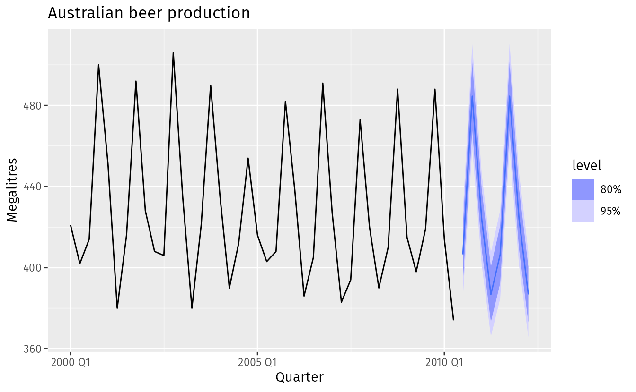
Figure 1.1: Australian quarterly beer production: 2000Q1–2010Q2, with two years of forecasts.
The blue lines show forecasts for the next two years. Notice how the forecasts have captured the seasonal pattern seen in the historical data and replicated it for the next two years. The dark shaded region shows 80% prediction intervals. That is, each future value is expected to lie in the dark shaded region with a probability of 80%. The light shaded region shows 95% prediction intervals. These prediction intervals are a useful way of displaying the uncertainty in forecasts. In this case the forecasts are expected to be accurate, and hence the prediction intervals are quite narrow.
The simplest time series forecasting methods use only information on the variable to be forecast, and make no attempt to discover the factors that affect its behaviour. Therefore they will extrapolate trend and seasonal patterns, but they ignore all other information such as marketing initiatives, competitor activity, changes in economic conditions, and so on.
Decomposition methods are helpful for studying the trend and seasonal patterns in a time series; these are discussed in Chapter 3. Popular time series models used for forecasting include exponential smoothing models and ARIMA models, discussed in Chapters 8 and 9 respectively.

Predictor variables and time series forecasting
Predictor variables are often useful in time series forecasting. For example, suppose we wish to forecast the hourly electricity demand (ED) of a hot region during the summer period. A model with predictor variables might be of the formED=f(current temperature, strength of economy, population,time of day, day of week, error).ED=�(current temperature, strength of economy, population,time of day, day of week, error).The relationship is not exact — there will always be changes in electricity demand that cannot be accounted for by the predictor variables. The “error” term on the right allows for random variation and the effects of relevant variables that are not included in the model. We call this an explanatory model because it helps explain what causes the variation in electricity demand.
Because the electricity demand data form a time series, we could also use a time series model for forecasting. In this case, a suitable time series forecasting equation is of the formEDt+1=f(EDt,EDt−1,EDt−2,EDt−3,…,error),ED�+1=�(ED�,ED�−1,ED�−2,ED�−3,…,error),where t� is the present hour, t+1�+1 is the next hour, t−1�−1 is the previous hour, t−2�−2 is two hours ago, and so on. Here, prediction of the future is based on past values of a variable, but not on external variables that may affect the system. Again, the “error” term on the right allows for random variation and the effects of relevant variables that are not included in the model.
There is also a third type of model which combines the features of the above two models. For example, it might be given byEDt+1=f(EDt,current temperature, time of day, day of week, error).ED�+1=�(ED�,current temperature, time of day, day of week, error).These types of mixed models have been given various names in different disciplines. They are known as dynamic regression models, panel data models, longitudinal models, transfer function models, and linear system models (assuming that f� is linear). These models are discussed in Chapter 10.
An explanatory model is useful because it incorporates information about other variables, rather than only historical values of the variable to be forecast. However, there are several reasons a forecaster might select a time series model rather than an explanatory or mixed model. First, the system may not be understood, and even if it was understood it may be extremely difficult to measure the relationships that are assumed to govern its behaviour. Second, it is necessary to know or forecast the future values of the various predictors in order to be able to forecast the variable of interest, and this may be too difficult. Third, the main concern may be only to predict what will happen, not to know why it happens. Finally, the time series model may give more accurate forecasts than an explanatory or mixed model.
The model to be used in forecasting depends on the resources and data available, the accuracy of the competing models, and the way in which the forecasting model is to be used.

Some case studies

The following four cases are from our consulting practice and demonstrate different types of forecasting situations and the associated challenges that often arise.

Case 1
The client was a large company manufacturing disposable tableware such as napkins and paper plates. They needed forecasts of each of hundreds of items every month. The time series data showed a range of patterns, some with trends, some seasonal, and some with neither. At the time, they were using their own software, written in-house, but it often produced forecasts that did not seem sensible. The methods that were being used were the following:
- average of the last 12 months data;
- average of the last 6 months data;
- prediction from a straight line regression over the last 12 months;
- prediction from a straight line regression over the last 6 months;
- prediction obtained by a straight line through the last observation with slope equal to the average slope of the lines connecting last year’s and this year’s values;
- prediction obtained by a straight line through the last observation with slope equal to the average slope of the lines connecting last year’s and this year’s values, where the average is taken only over the last 6 months.
They required us to tell them what was going wrong and to modify the software to provide more accurate forecasts. The software was written in COBOL, making it difficult to do any sophisticated numerical computation.

Case 2
In this case, the client was the Australian federal government, which needed to forecast the annual budget for the Pharmaceutical Benefit Scheme (PBS). The PBS provides a subsidy for many pharmaceutical products sold in Australia, and the expenditure depends on what people purchase during the year. The total expenditure was around A$7 billion in 2009, and had been underestimated by nearly $1 billion in each of the two years before we were asked to assist in developing a more accurate forecasting approach.
In order to forecast the total expenditure, it is necessary to forecast the sales volumes of hundreds of groups of pharmaceutical products using monthly data. Almost all of the groups have trends and seasonal patterns. The sales volumes for many groups have sudden jumps up or down due to changes in what drugs are subsidised. The expenditures for many groups also have sudden changes due to cheaper competitor drugs becoming available.
Thus we needed to find a forecasting method that allowed for trend and seasonality if they were present, and at the same time was robust to sudden changes in the underlying patterns. It also needed to be able to be applied automatically to a large number of time series.

Case 3
A large car fleet company asked us to help them forecast vehicle resale values. They purchase new vehicles, lease them out for three years, and then sell them. Better forecasts of vehicle sales values would mean better control of profits; understanding what affects resale values may allow leasing and sales policies to be developed in order to maximise profits.
At the time, the resale values were being forecast by a group of specialists. Unfortunately, they saw any statistical model as a threat to their jobs, and were uncooperative in providing information. Nevertheless, the company provided a large amount of data on previous vehicles and their eventual resale values.

Case 4
In this project, we needed to develop a model for forecasting weekly air passenger traffic on major domestic routes for one of Australia’s leading airlines. The company required forecasts of passenger numbers for each major domestic route and for each class of passenger (economy class, business class and first class). The company provided weekly traffic data from the previous six years.
Air passenger numbers are affected by school holidays, major sporting events, advertising campaigns, competition behaviour, etc. School holidays often do not coincide in different Australian cities, and sporting events sometimes move from one city to another. During the period of the historical data, there was a major pilots’ strike during which there was no traffic for several months. A new cut-price airline also launched and folded. Towards the end of the historical data, the airline had trialled a redistribution of some economy class seats to business class, and some business class seats to first class. After several months, however, the seat classifications reverted to the original distribution.

1.6 The basic steps in a forecasting task
A forecasting task usually involves five basic steps.
Step 1: Problem definition.
Often this is the most difficult part of forecasting. Defining the problem carefully requires an understanding of the way the forecasts will be used, who requires the forecasts, and how the forecasting function fits within the organisation requiring the forecasts. A forecaster needs to spend time talking to everyone who will be involved in collecting data, maintaining databases, and using the forecasts for future planning.
Step 2: Gathering information.
There are always at least two kinds of information required: (a) statistical data, and (b) the accumulated expertise of the people who collect the data and use the forecasts. Often, it will be difficult to obtain enough historical data to be able to fit a good statistical model. In that case, the judgmental forecasting methods of Chapter 6 can be used. Occasionally, old data will be less useful due to structural changes in the system being forecast; then we may choose to use only the most recent data. However, remember that good statistical models will handle evolutionary changes in the system; don’t throw away good data unnecessarily.
Step 3: Preliminary (exploratory) analysis.
Always start by graphing the data. Are there consistent patterns? Is there a significant trend? Is seasonality important? Is there evidence of the presence of business cycles? Are there any outliers in the data that need to be explained by those with expert knowledge? How strong are the relationships among the variables available for analysis? Various tools have been developed to help with this analysis. These are discussed in Chapters 2 and 3.
Step 4: Choosing and fitting models.
The best model to use depends on the availability of historical data, the strength of relationships between the forecast variable and any explanatory variables, and the way in which the forecasts are to be used. It is common to compare two or three potential models. Each model is itself an artificial construct that is based on a set of assumptions (explicit and implicit) and usually involves one or more parameters which must be estimated using the known historical data. We will discuss regression models (Chapter 7), exponential smoothing methods (Chapter 8), Box-Jenkins ARIMA models (Chapter 9), Dynamic regression models (Chapter 10), Hierarchical forecasting (Chapter 11), and several advanced methods including neural networks and vector autoregression (Chapter 12).
Step 5: Using and evaluating a forecasting model.
Once a model has been selected and its parameters estimated, the model is used to make forecasts. The performance of the model can only be properly evaluated after the data for the forecast period have become available. A number of methods have been developed to help in assessing the accuracy of forecasts. There are also organisational issues in using and acting on the forecasts. A brief discussion of some of these issues is given in Chapter 5. When using a forecasting model in practice, numerous practical issues arise such as how to handle missing values and outliers, or how to deal with short time series. These are discussed in Chapter 13.

1.7 The statistical forecasting perspective

The thing we are trying to forecast is unknown (or we would not be forecasting it), and so we can think of it as a random variable. For example, the total sales for next month could take a range of possible values, and until we add up the actual sales at the end of the month, we don’t know what the value will be. So until we know the sales for next month, it is a random quantity.
Because next month is relatively close, we usually have a good idea what the likely sales values could be. On the other hand, if we are forecasting the sales for the same month next year, the possible values it could take are much more variable. In most forecasting situations, the variation associated with the thing we are forecasting will shrink as the event approaches. In other words, the further ahead we forecast, the more uncertain we are.
We can imagine many possible futures, each yielding a different value for the thing we wish to forecast. Plotted in black in Figure 1.2 are the total international arrivals to Australia from 1980 to 2015. Also shown are ten possible futures from 2016–2025.
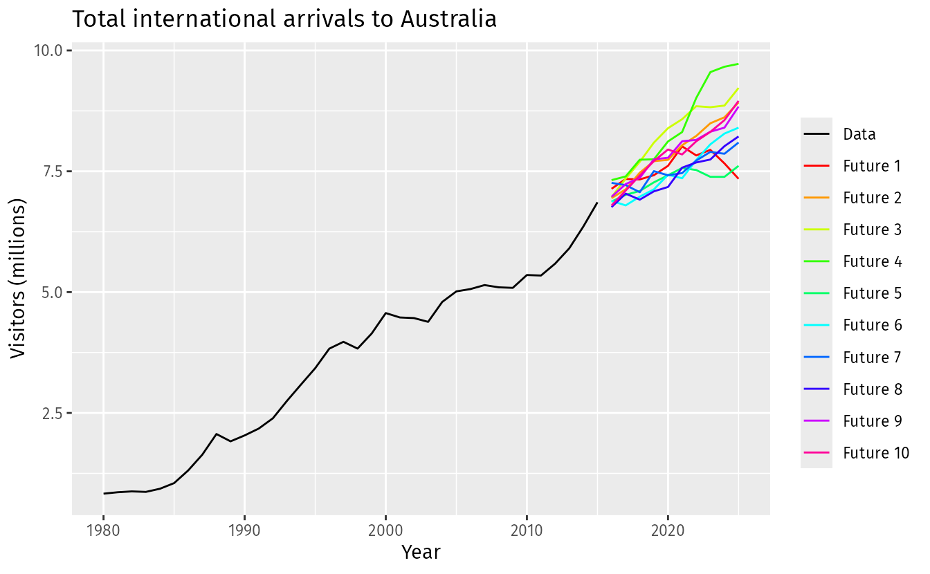
Figure 1.2: Total international visitors to Australia (1980-2015) along with ten possible futures.
When we obtain a forecast, we are estimating the middle of the range of possible values the random variable could take. Often, a forecast is accompanied by a prediction interval giving a range of values the random variable could take with relatively high probability. For example, a 95% prediction interval contains a range of values which should include the actual future value with probability 95%.
Rather than plotting individual possible futures as shown in Figure 1.2, we usually show these prediction intervals instead. Figure 1.3 shows 80% and 95% intervals for the future Australian international visitors. The blue line is the average of the possible future values, which we call the point forecasts.
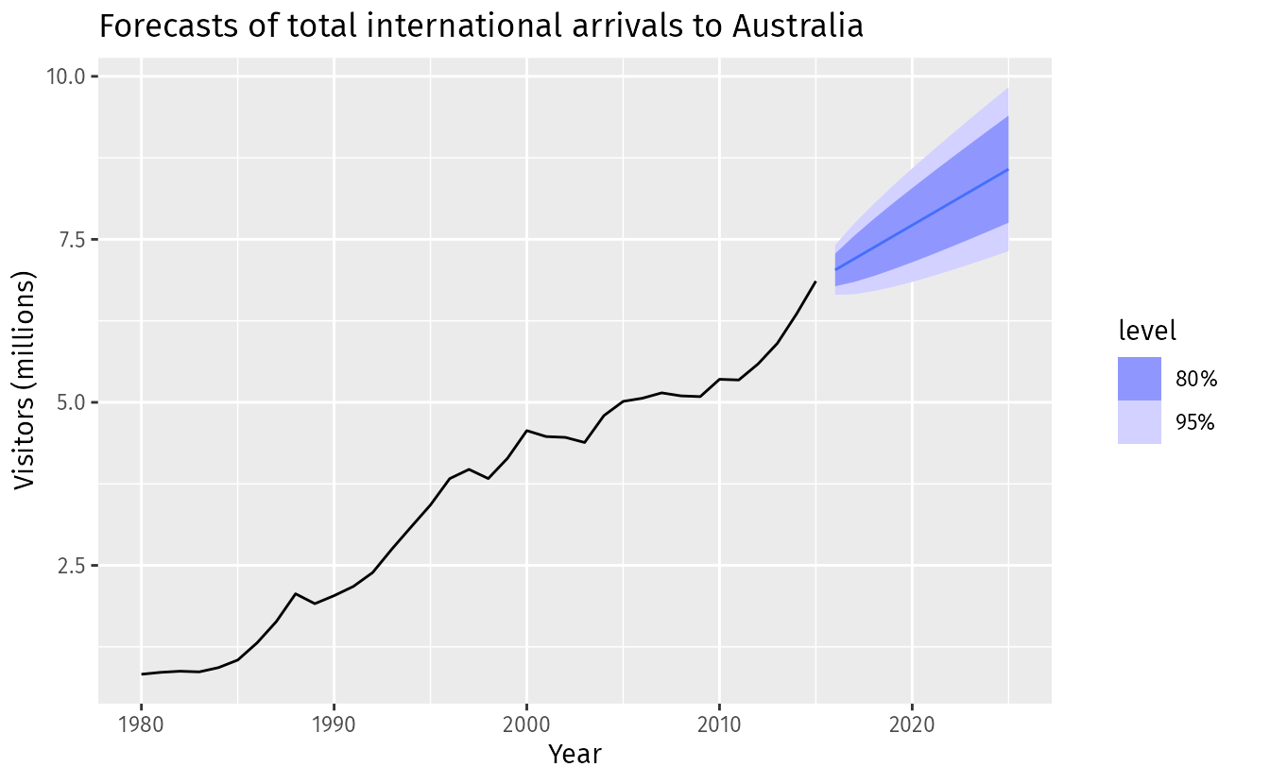
Figure 1.3: Total international visitors to Australia (1980–2015) along with 10-year forecasts and 80% and 95% prediction intervals.
We will use the subscript t� for time. For example, yt�� will denote the observation at time t�. Suppose we denote all the information we have observed as I� and we want to forecast yt��. We then write yt|I��|� meaning “the random variable yt�� given what we know in I�”. The set of values that this random variable could take, along with their relative probabilities, is known as the “probability distribution” of yt|I��|�. In forecasting, we call this the forecast distribution.
When we talk about the “forecast”, we usually mean the average value of the forecast distribution, and we put a “hat” over y� to show this. Thus, we write the forecast of yt�� as ^yt�^�, meaning the average of the possible values that yt�� could take given everything we know.
It is often useful to specify exactly what information we have used in calculating the forecast. Then we will write, for example, ^yt|t−1�^�|�−1 to mean the forecast of yt�� taking account of all previous observations (y1,…,yt−1)(�1,…,��−1). Similarly, ^yT+h|T�^�+ℎ|� means the forecast of yT+h��+ℎ taking account of y1,…,yT�1,…,�� (i.e., an hℎ-step forecast taking account of all observations up to time T�).

Bibliography
Armstrong, J. S. (Ed.). (2001). Principles of forecasting: A handbook for researchers and practitioners. Kluwer Academic Publishers.
Ord, J. K., Fildes, R., & Kourentzes, N. (2017). Principles of business forecasting (2nd ed.). Wessex Press Publishing Co

